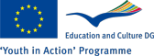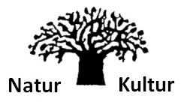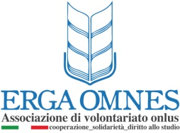

Sustainability, Capacity and Development Camp
Training course
31 March - 8 April 2013 | North Germany, Germany

Training course for youth leaders for building the capacity of their NGOs trough simulations, outdoor activities, small working groups and competitions within the group. Learning by doing training with experienced trainers.
Sustainability, capacity and development camp is a training course that is going to be held near Bremen in March 2013 where 42 youth workers from 6 different countries(Germany, Italy, Cyprus, Romania, Switzerland and Turkey) are going to participate. The objectives of the project are to provide organizational tools to the NGOs from these countries and their key people(participants target group) knowledge and experience for how to make their organizations develop(grow in numbers and performance), increase their capacity(financial, managerial etc) and be more sustainable on long term. We are going to have simulations, outdoor activities, workshops, small working groups, presentations. The training will last 8 days from 30th of March to 7th of April.
Working language: English
Cost: The fee for this training is 20€ for participants from all countries. The participants will have covered costs for food and accommodation, and 70% of their travel tickets will be covered if they are not more than:
- Romania 400€
- Turkey 500€
- Switzerland 350€
- Italy 350€
- Cyprus 500€
For Turkish participants the VISA costs will be covered 100% if they are not more than 80€ per person.

